1. **ALL USERS SCREEN**

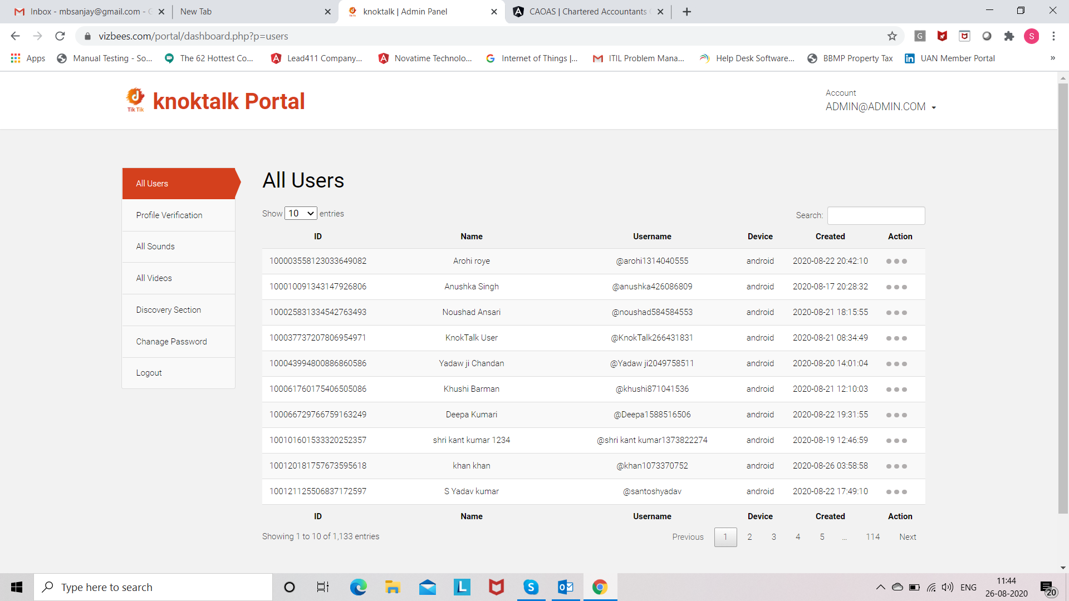

**In the Action 🡪 You have give BLOCK & UNBLOCK, DELETE OPTION.**

1. **PROFILE VERFICATION SCREEN**

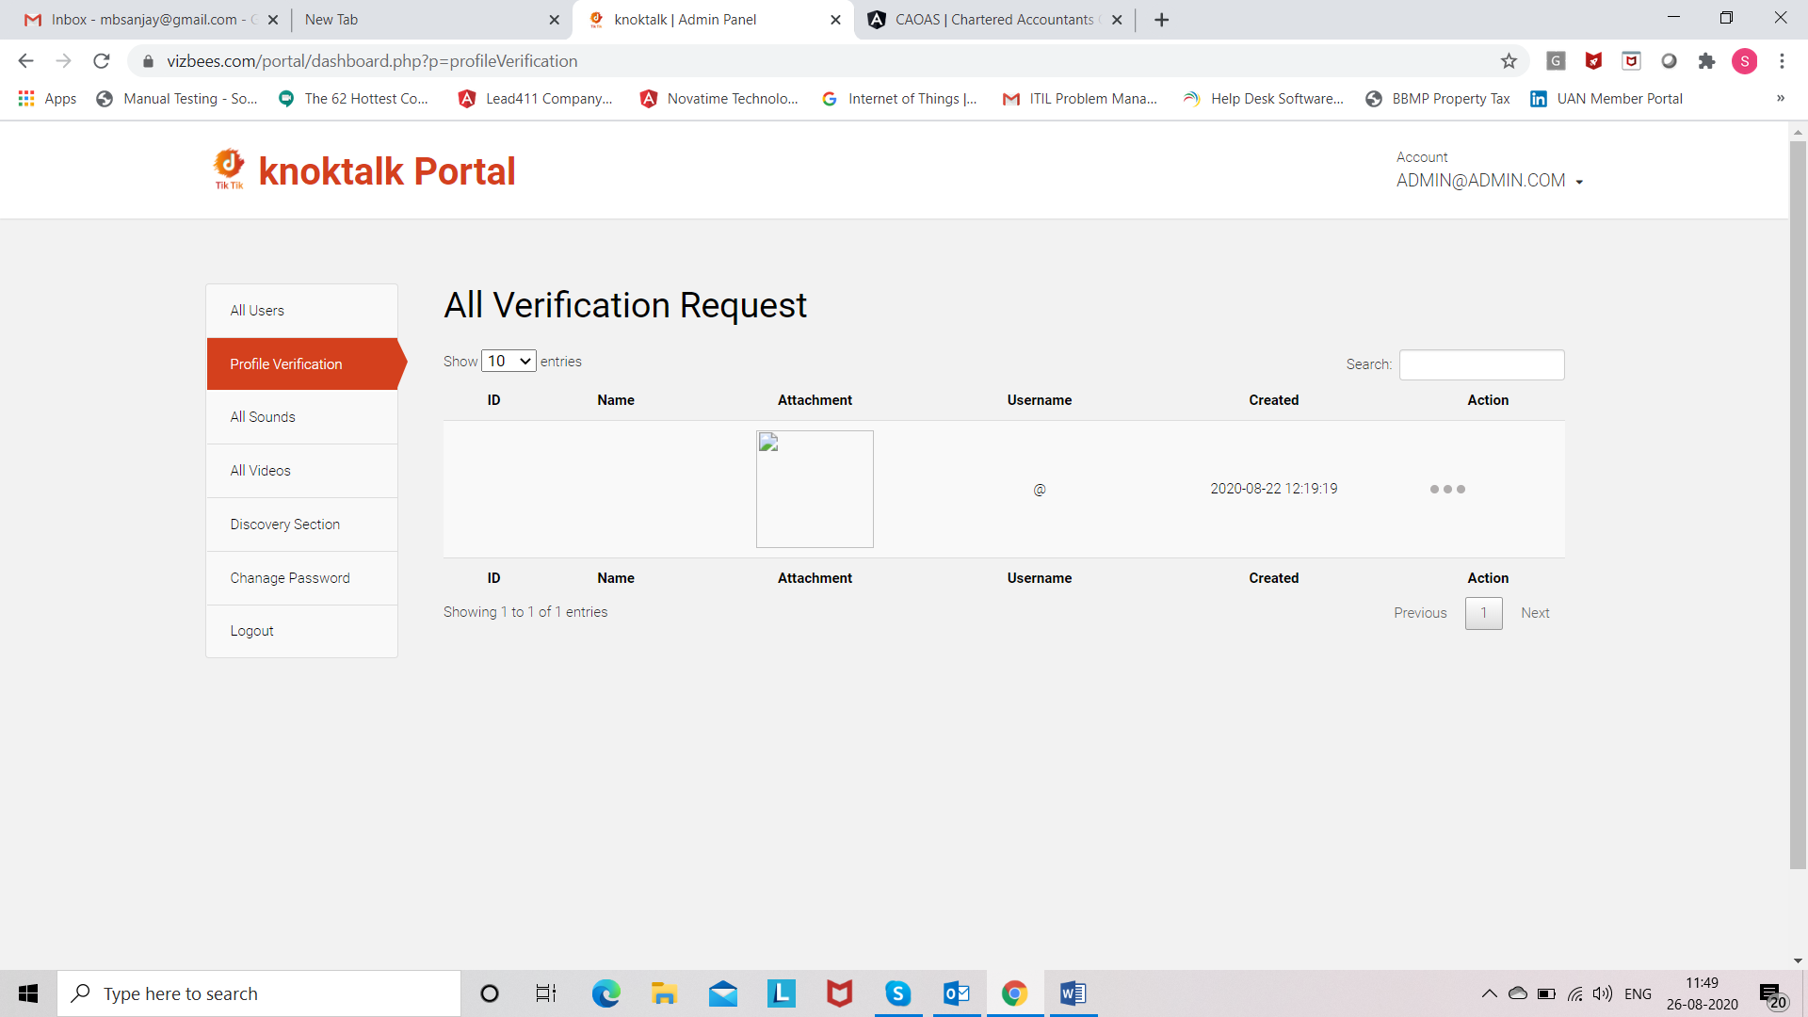

**In the Action 🡪 You have to give APPROVE OR DECLINE. At present it is showing as only Profile at a time but need to display all the profiles.**

1. **ALL SOUND SCREEN**

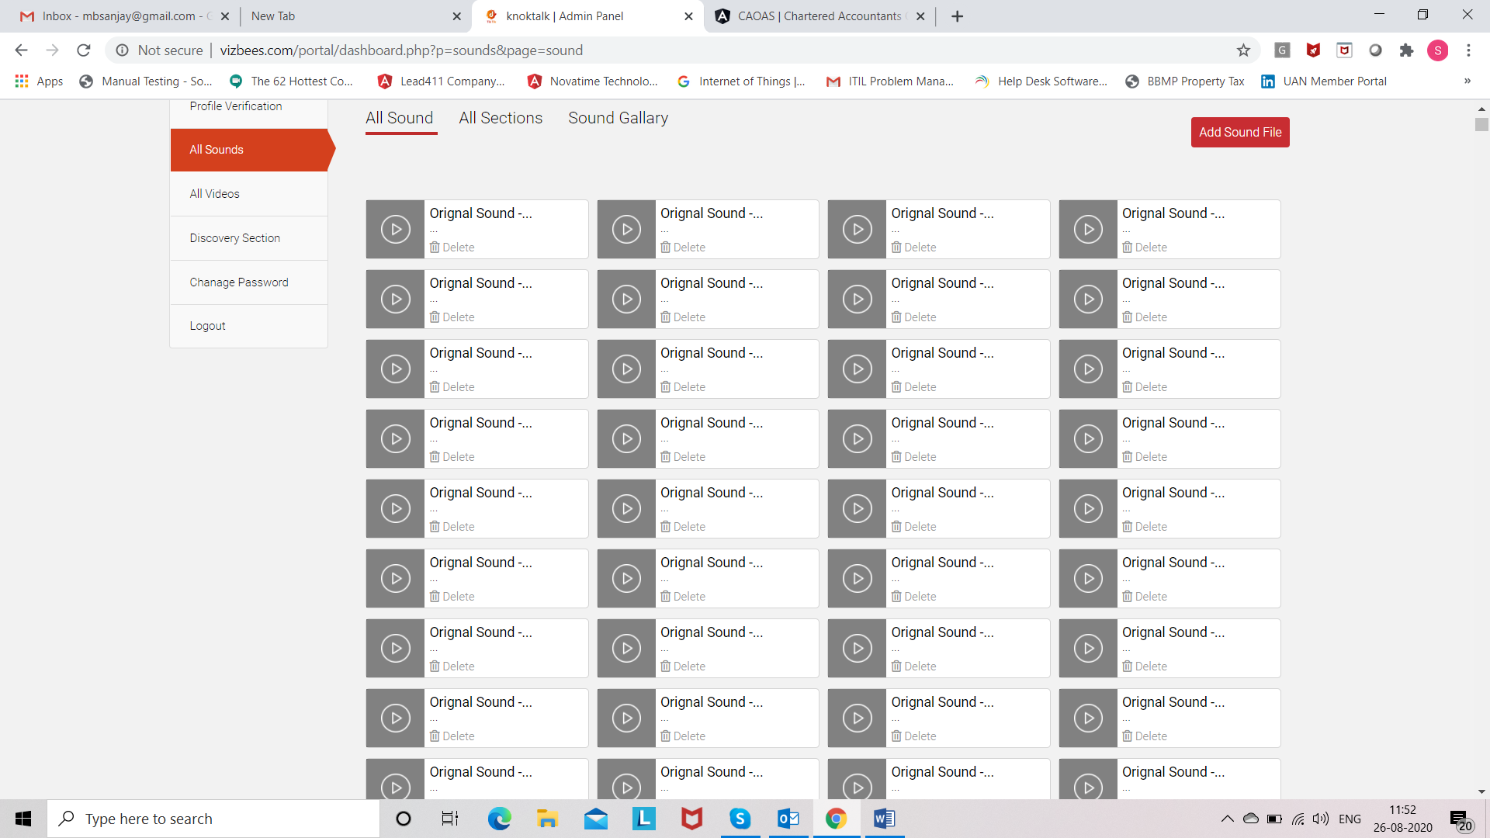

1. **ADD SOUND SCREEN**

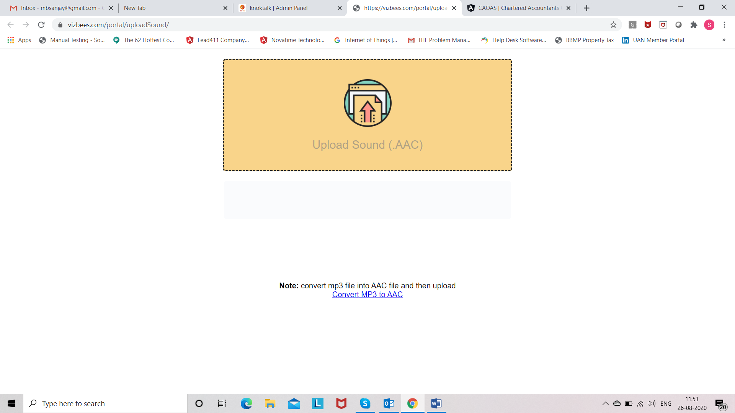

**NOTE: Before uploading sound file you need to convert into .AAC file.**

1. **ALL SECTIONS**

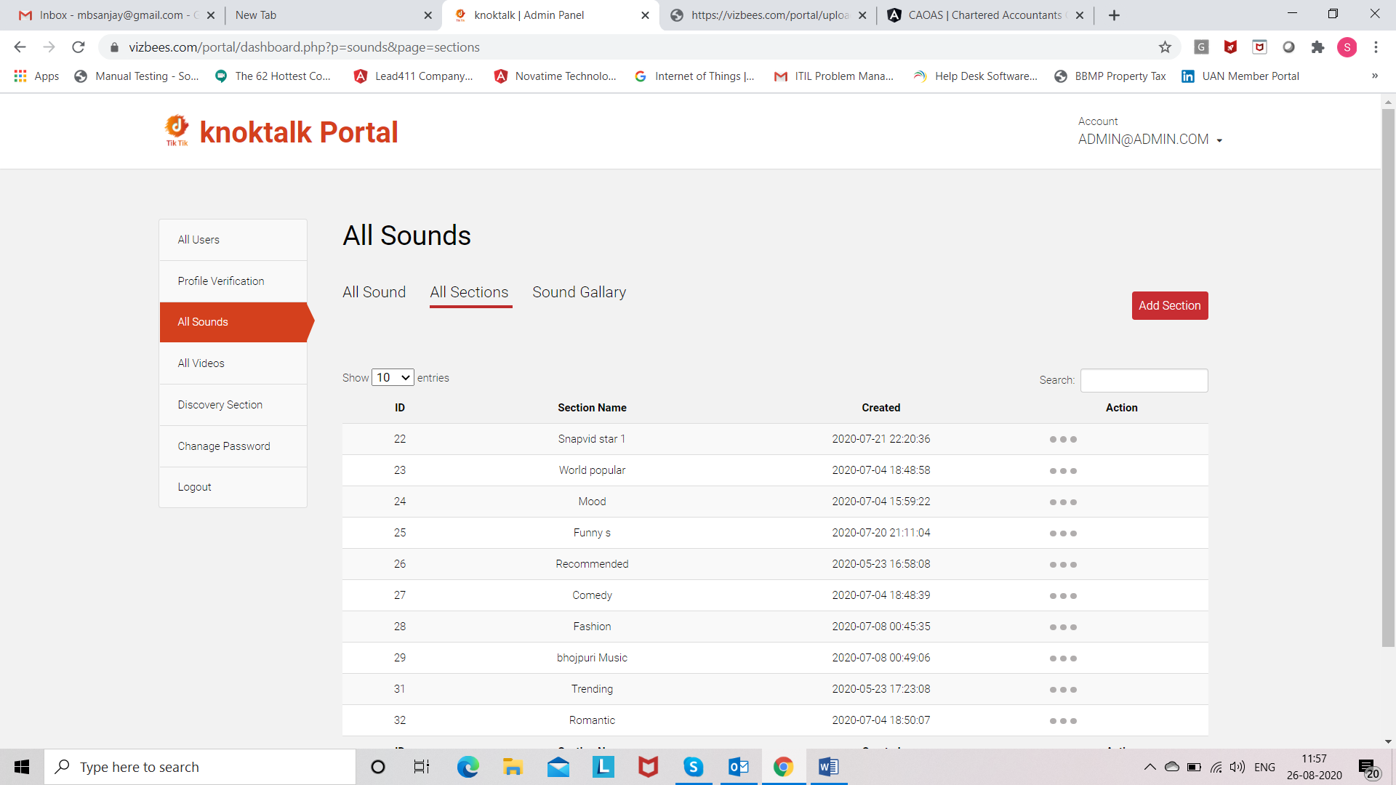

**In the Action 🡪 display EDIT and DELETE button in the action.**

1. **ADD SECTION**

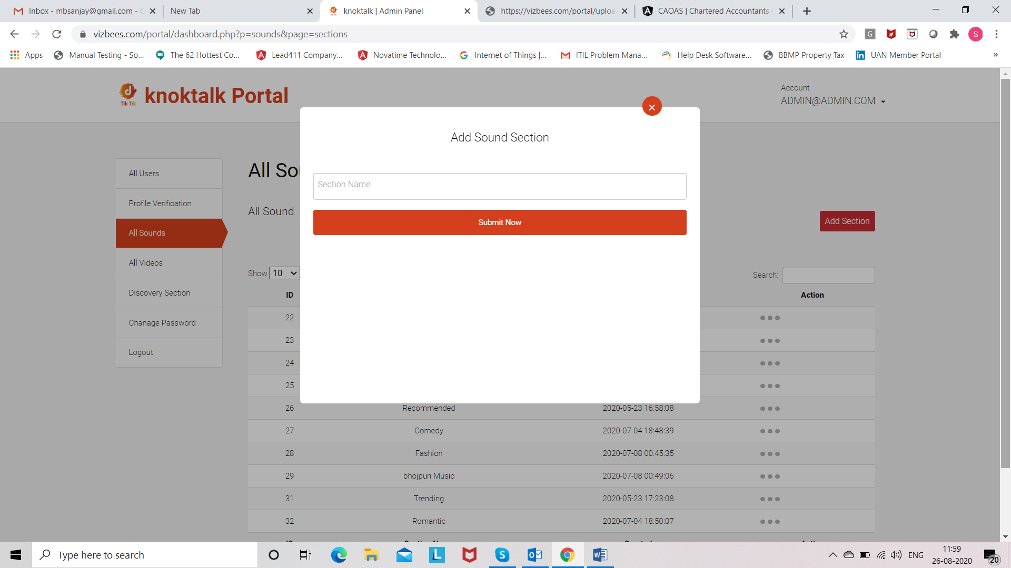

1. **SOUND GALLERY**

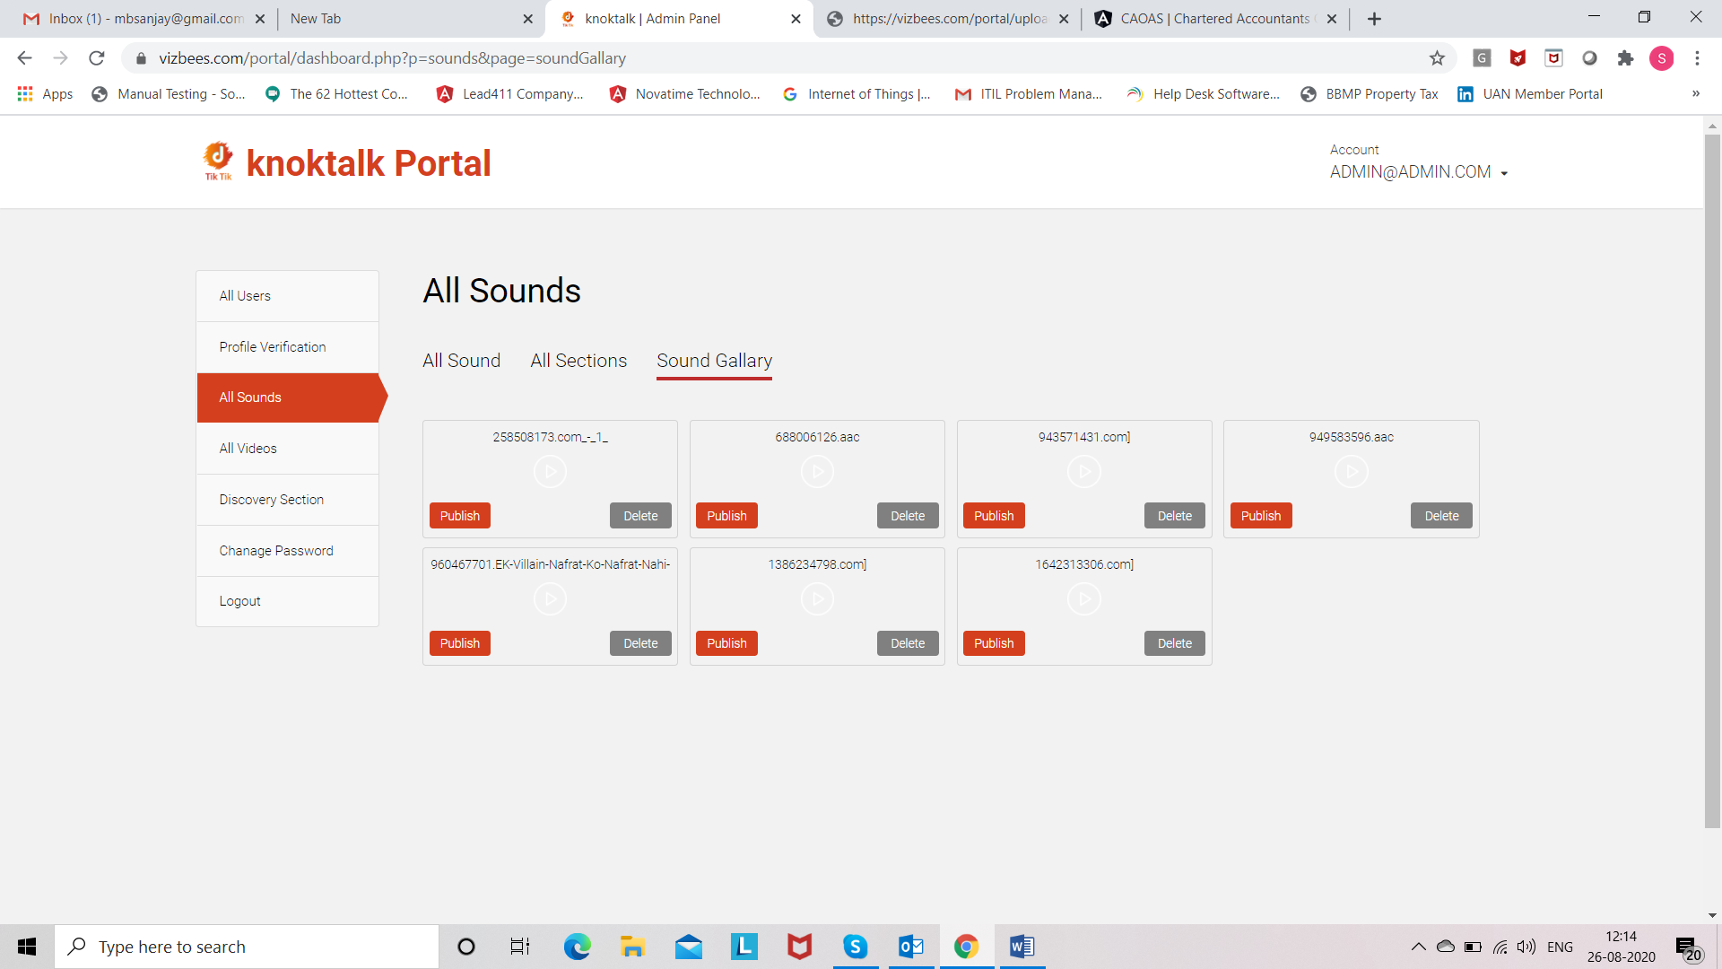

**DISPLAY ALL THE UPLOAD SOUNDS IN THE .AAC FORMAT. IN THE ACTION DISPLAY PUBLISH AND DELETE BUTTONS.**

1. **ALL VIDEOS**

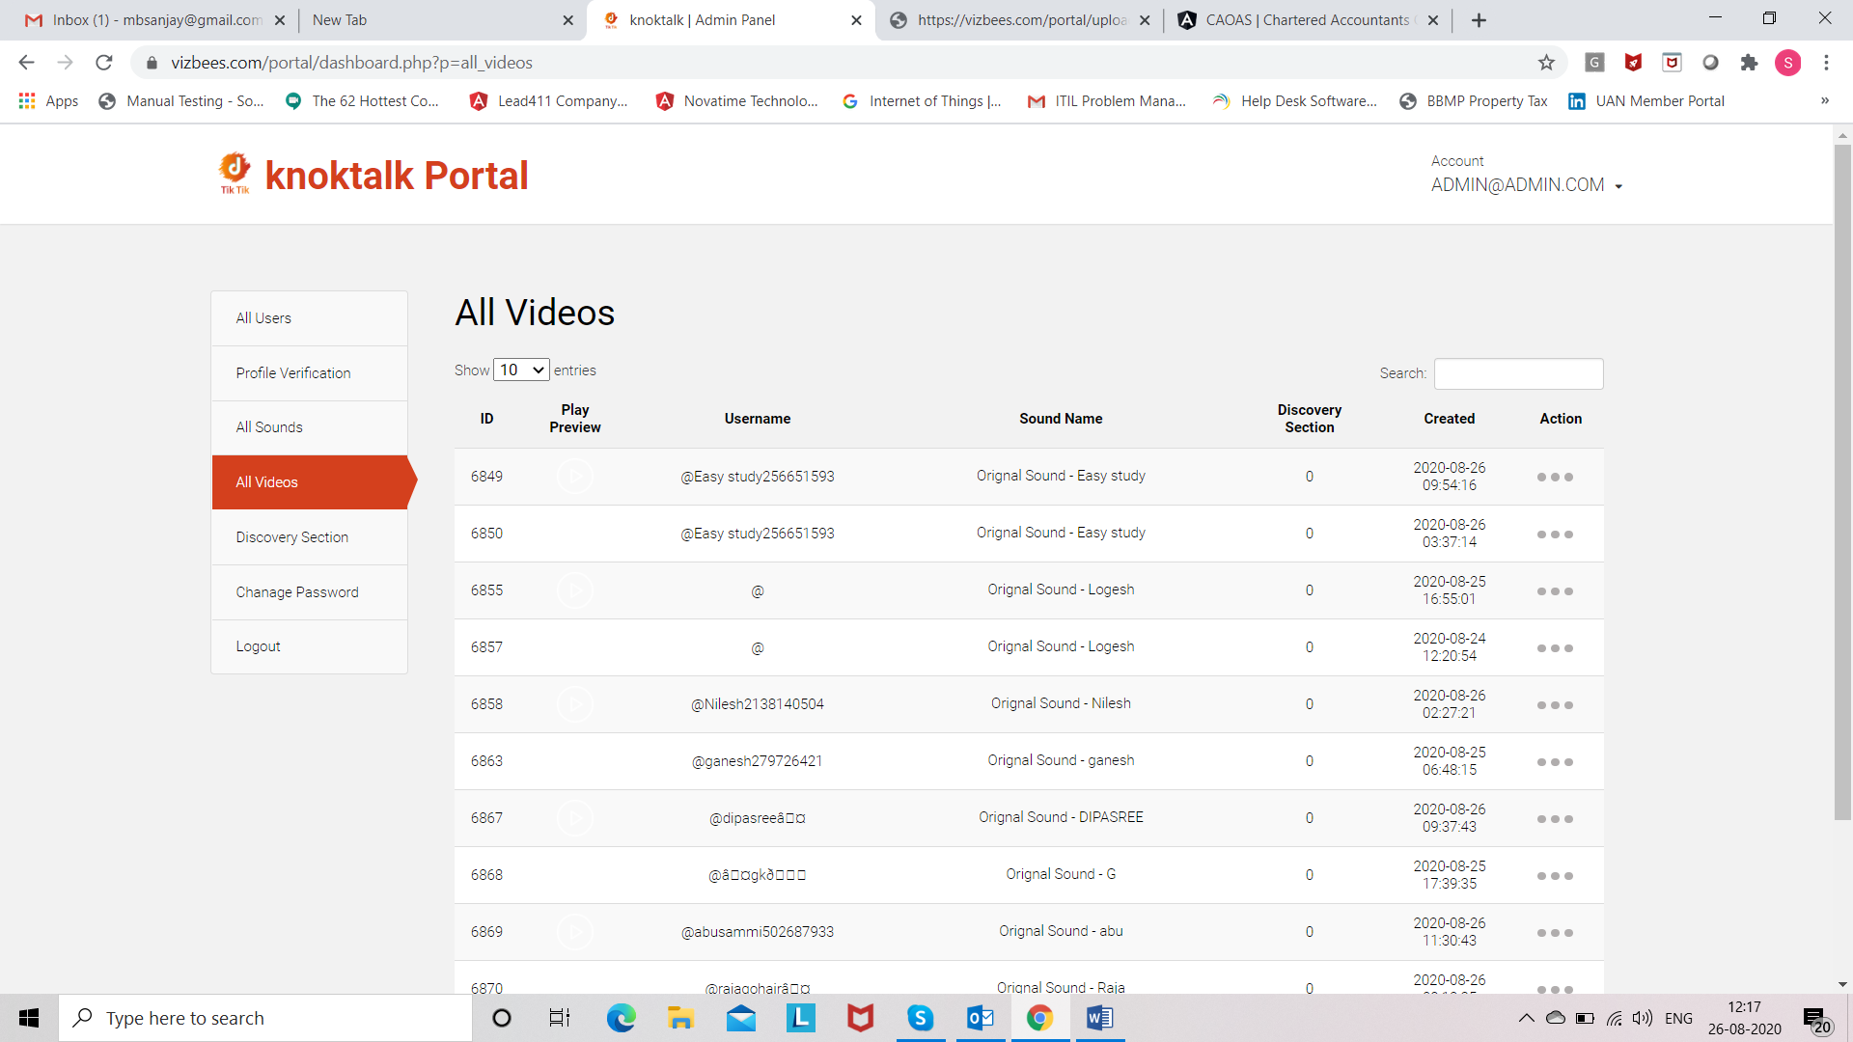

**IN THE ACTION DISPLAY “ADD TO DISCOVERY” AND “DELETE” BUTTON.**

**When you click on ADD TO DISCOVERY then show the below mentioned screen.**

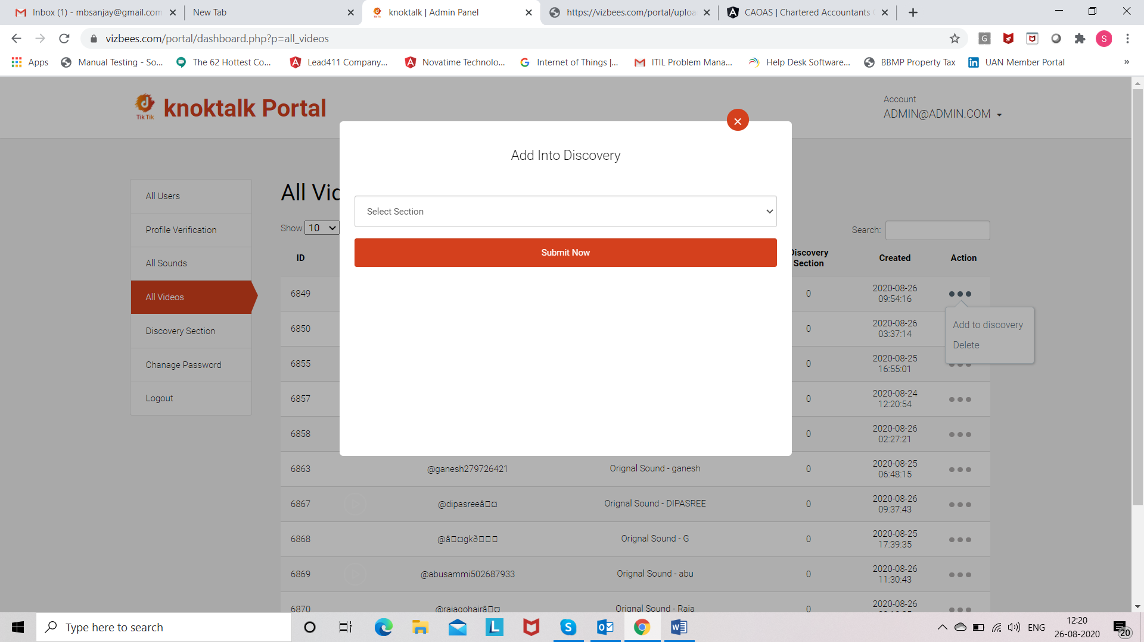

1. **DISCOVERY SECTION**

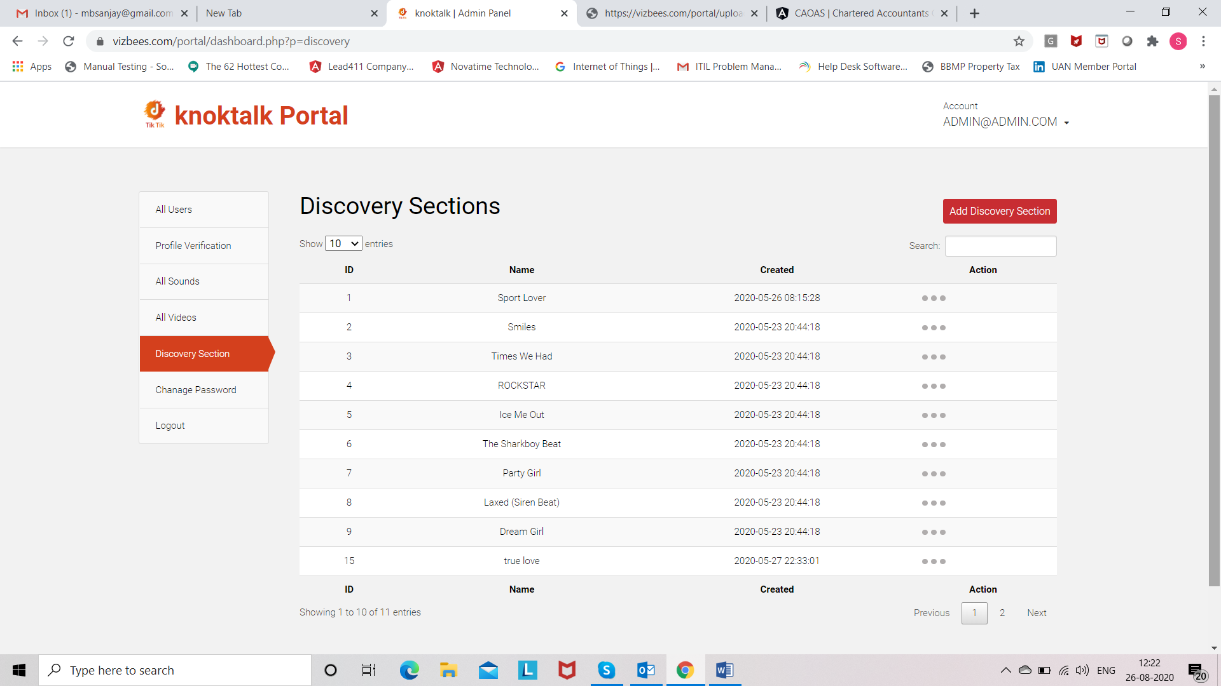

**In the Action 🡪 Display EDIT and DELETE button.**

1. **ADD DISCOVERY SECTION**

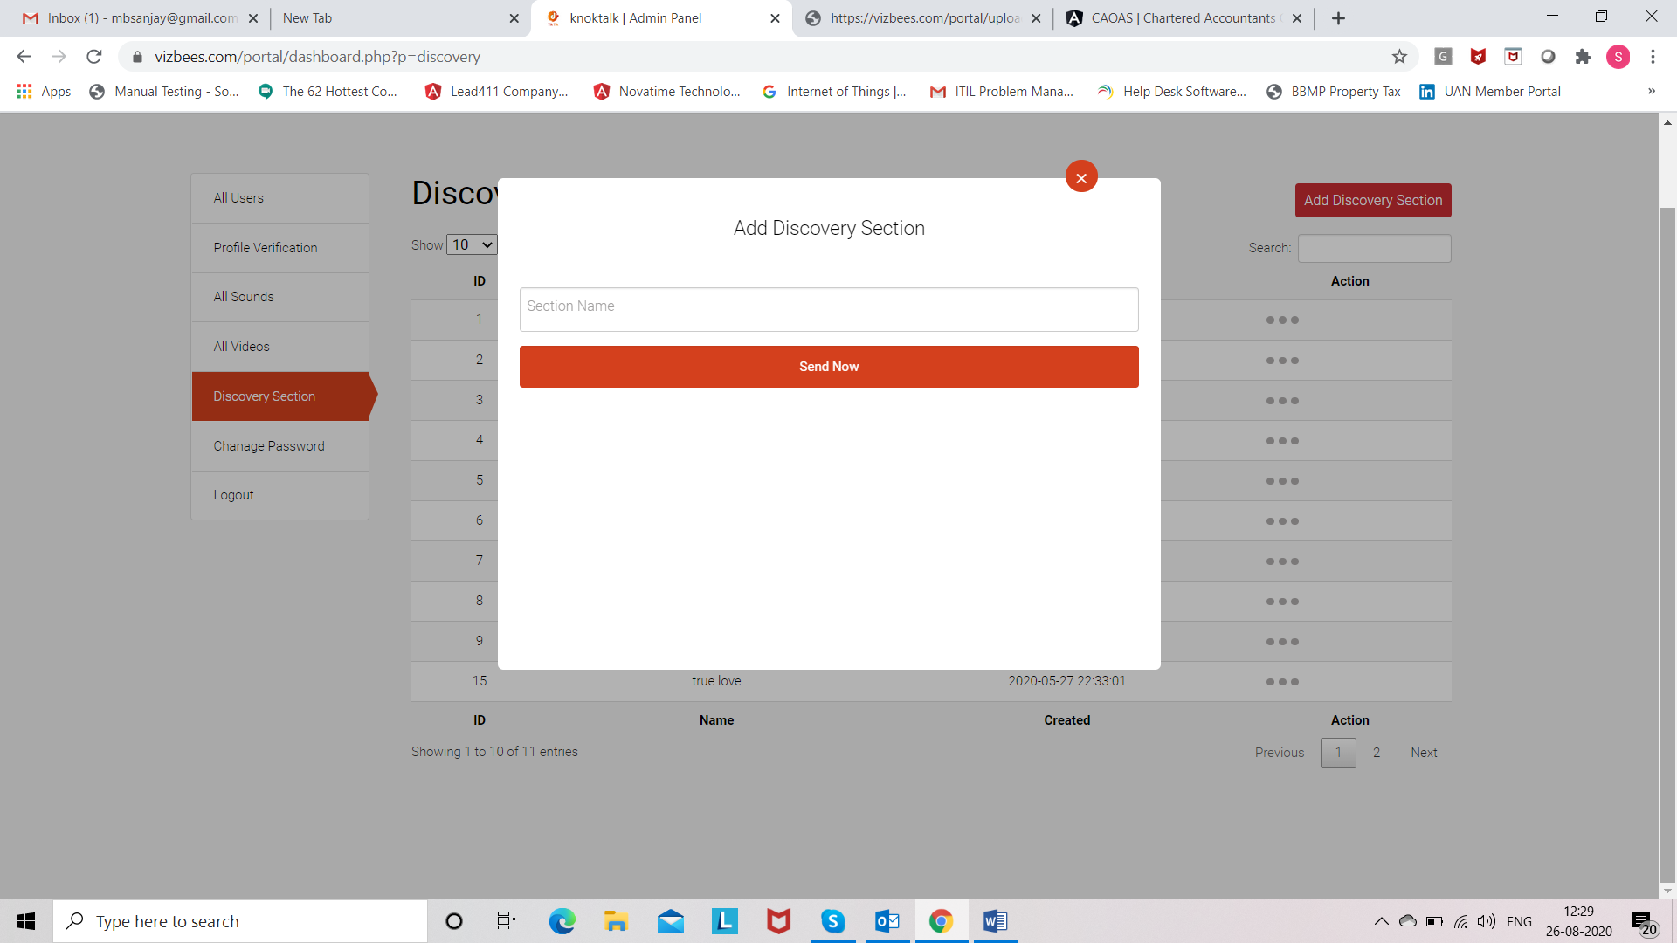

1. **CHANGE PASSWORD**

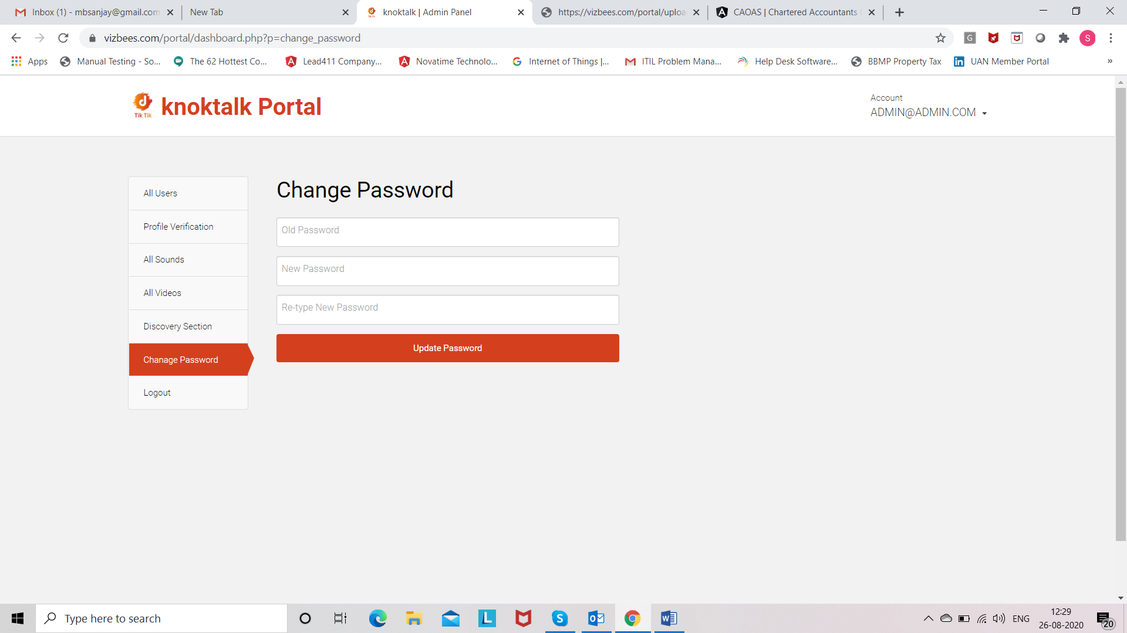

1. **In the End show LogOut button.**